 | THE SUN | EVENING STANDARD
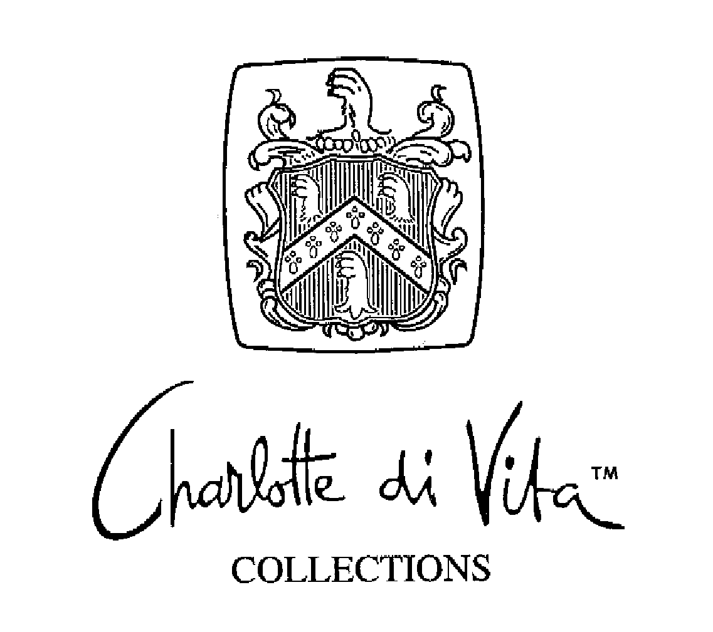  Charlotte di Vita – Woman of the Year Oct 03. | 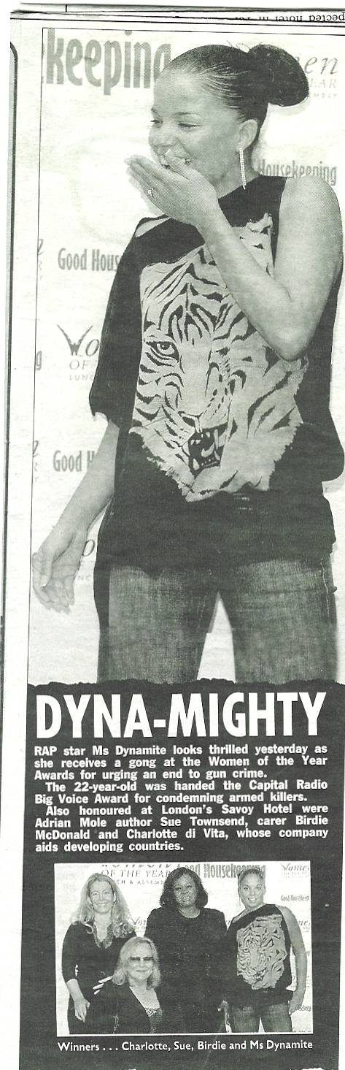 | 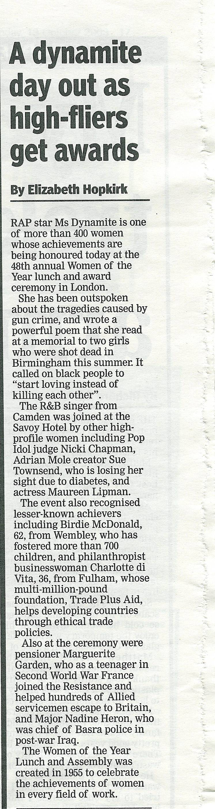
DAILY TELEGRAPH

