

DINH QUAN MEDICAL STATION

ANNUAL UPDATE REPORT 2003

Established: | August 1997
Location: | Gia Canh Village, Dinh Quan District, Dong Nai Province (2 hours drive North HCM City)
Target Group: | Poor children & disadvantaged families
Local Partner: | The Peoples Committee of Dinh Quan
CNCF Staff: | Ms. Son Thu Trinh & Mr. Dan
Current Staffing: | Local officials
Method Of Funding: | Bi-annually
CNCF Intervention 2001: | Continuous
Future Intervention: | Ongoing

PROJECT DESCRIPTION:
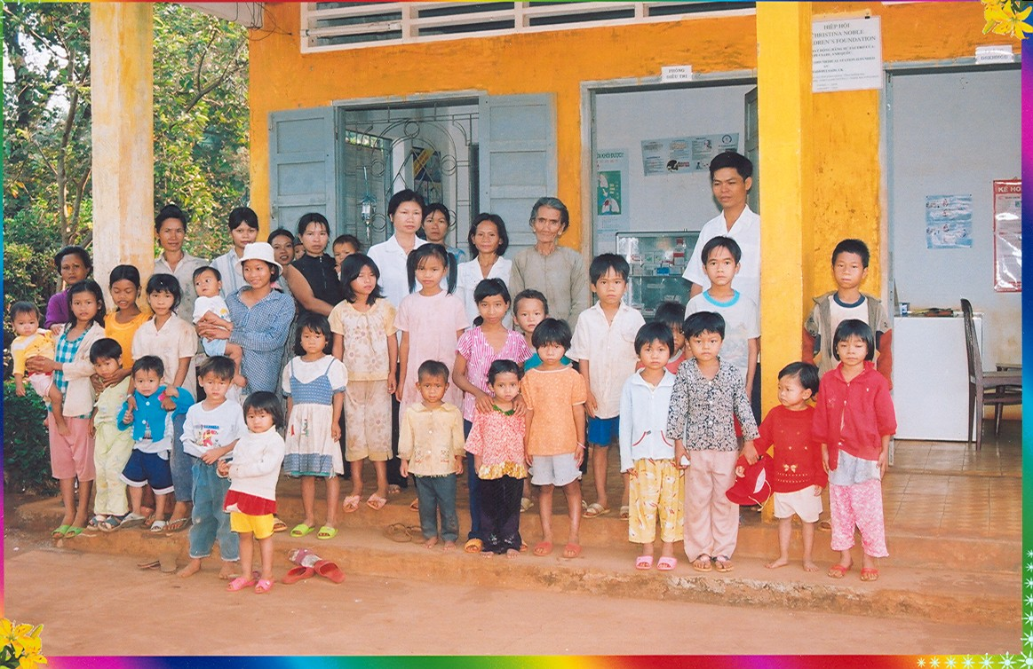
In August 1997, the Foundation opened this First Aid Medical Station, and provided a generator and electric water pump for its water well. Commonly treated illnesses at the Medical Station are: Respiratory illness, Malaria, Diarrhea, Gastrointestinal infection and Dysentery. It also serves the mothers of Gia Canh village providing both delivery and post-natal care. Staff at the Medical Station, also provide preventative services including education regarding the importance of personal sanitation, health and hygiene. The Medical Station operates 5 days a week and is staffed by one doctor, a nurse and an assistant.
At the Station

REPORTING PERIOD: January – December 2003

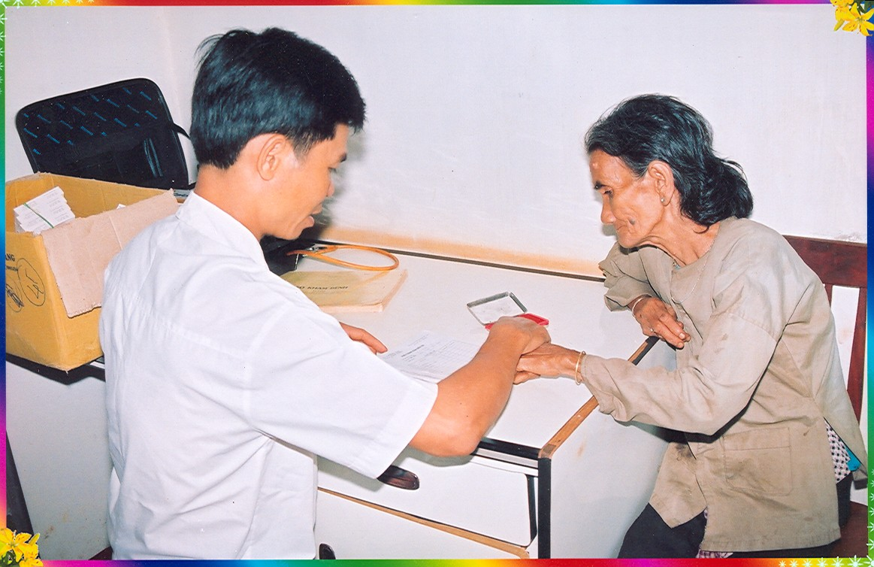
In 2003, 1,249 patients were received at the clinic, resulting in a total of 4,299 consultations. Once again, the majority of these patients were suffering from respiratory illness. 649 patients were treated during the period and provided free of charge with the medicines they required. The malaria prevention initiatives adopted by the clinic have played a significant role in decreasing the incidents of malaria in the community. Mosquito nets re-spraying and termite destruction has been conducted 3 times this year in June, October and the latest December. All 310 families located in the District benefited from the campaign, with 1,550 mosquito nets re-sprayed for 1244 people. Especially, in December, 449 new mosquito nets have been supplied to every household in the locality.
An elderly patient examined at the Station

COMMON TREATMENTS

 | Respiratory Illness | Digestive problems | Rheumatism | Gynaecological disease (examination and treatment) | Tonsillitis | Acute Respiratory Illness
Cases treated in 2003 | 172 | 86 | 80 | 165 | 121 | 137
Cases treated in 2002 | 188 | - | - | - | - | -
Cases treated in 2001 | 206 | - | - | - | - | -

The most remarkable development in the medical station’s activities during the last year related to tuberculosis. Because of the danger of infection with this disease, people suffering from symptoms of tuberculosis were given immediate attention and drugs at an early stage. Thanks to this policy, the number of tuberculosis patients didn’t increase from January to December with an average of 1 patient per month, a considerable achievement in an area where people’s living standards are still very low and their health easily damaged due to hard manual work.

FAMILY PLANNING

 | Prenatal Exam | Contraceptive Pill | Sterilisation | Condoms Supplied
Cases /Consultations in 2003 | 40 | 226 | 0 | 154
Cases / Consultations in 2002 | 65 | 68 | 1 | 92
Cases / Consultations in 2001 | 86 | 121 | 6 | 103

In 2003, family planning has developed considerably with a significant increase in the number of contraceptive pills and condoms supplied to couples in Dinh Quan District.

VACCINATIONS

Vaccination Type | Routine Child  Vaccination | Child Vaccination (under 12 months) | VAT (pregnant women) | VAT (women 15-35 years)
Cases treated in 2003 | 52 | 284 | 39 | 90
Cases treated in 2002 | 62 | 310 | 49 | 59
Case treated in 2001 | 52 | 343 | 49 | 153

