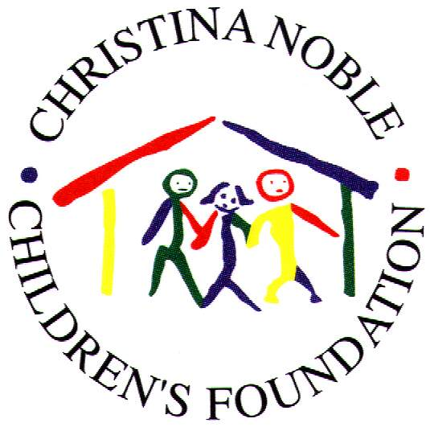

DINH QUAN MEDICAL STATION

SEMI ANNUAL UPDATE REPORT 2004

Established: | August 1997
Location: | Gia Canh Village, Dinh Quan District, Dong Nai Province (2 hours drive North HCM City)
Target Group: | Poor children & disadvantaged families
Local Partner: | The People’s Committee of Dinh Quan
CNCF Staff: | Ms. Son Thu Trinh & Mr. Tran Quynh Dan
Current Staffing: | Local officials
Method Of Funding: | Bi-annually
CNCF Intervention 2004: | Continuous
Future Intervention: | Ongoing
2004 Operating Budget: | $ 3,014.43

PROJECT DESCRIPTION:

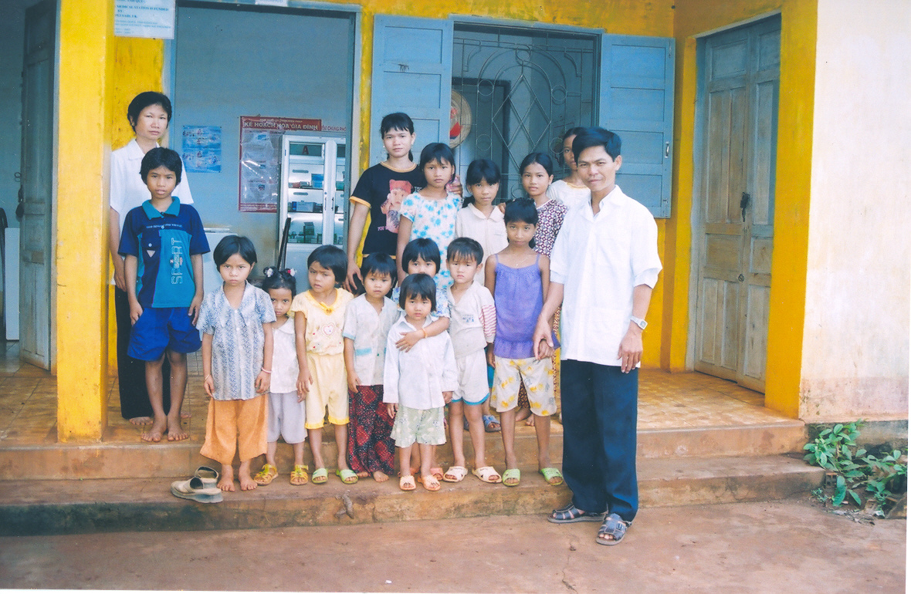
In August 1997, the Foundation opened this First Aid Medical Station, and provided a generator and electric water pump for its water well. Commonly treated illnesses at the Medical Station are: Respiratory illness, Malaria, Diarrhea, Gastrointestinal infection and Dysentery. It also serves the mothers of Gia Canh village by providing both delivery and post-natal care. Staff at the Medical Station also provides preventative services including education regarding the importance of personal sanitation, health and hygiene. The Medical Station operates 5 days a week and is staffed by one doctor, a nurse and an assistant.

At the Station

REPORTING PERIOD: January – June 2004

During the first 6 months of 2004, the Station has provided medical check-ups, treatment and medicine supply with 1,891 sessions to 445 patients, 326 of whom got the medicine they required free of charge. In comparison with the same period of 2003, the number of patients receiving free medicine has increased by 29.88% equivalent to 75 persons. This means more poor people in the community have got access to medical care, a target always put forth since the establishment of the Station.

COMMON TREATMENT

Because Gia Canh hamlet (Dinh Quan town) is located in a mountainous area, the number of patients suffering from malaria in the community has always taken up the most number of all patients. However, thanks to the malaria prevention program provided by the Station, by giving preventative medicine and mosquito-nests to local people, a great amount of people have been cured of this disease and a large amount of others were able to avoid catching malaria. In 6 months, 119 patients, taking up 26.74%, have been provided with medicine for malaria and 419 mosquito-nests have been given to the people there.

In addition, local people commonly suffered from the following diseases with their distribution represented in the chart below:

0
20
40
60
80
100
120
COMMON DISEASES
Malaria
Acute Respiratory Illness
Digestion problem
Tonsillitis
Leprosy
Rheumatism
Gynecology examination and treatment

FAMILY PLANNING

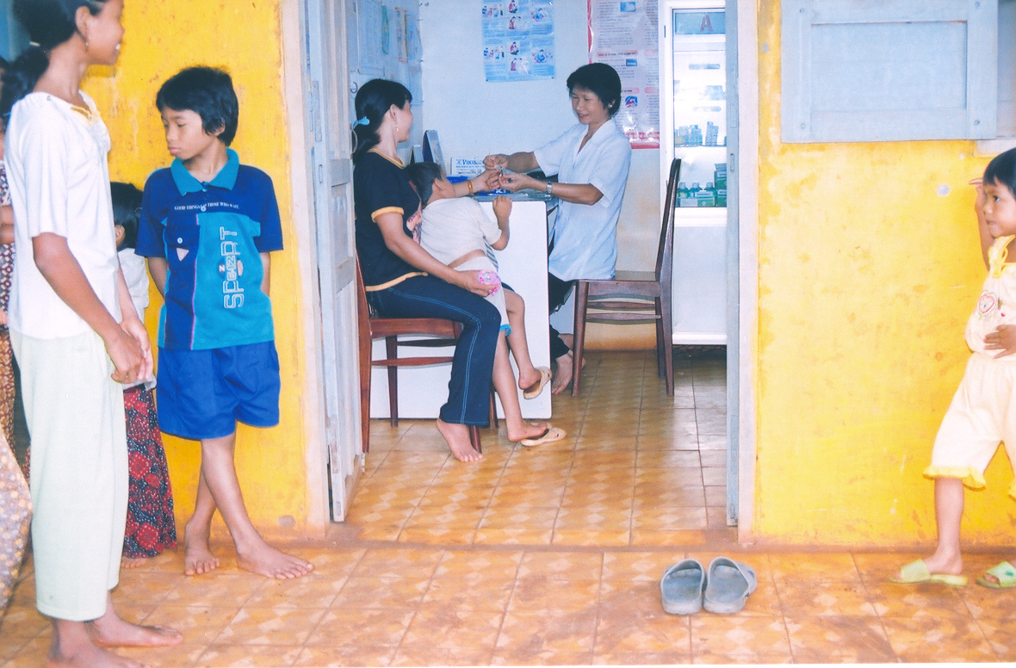
The medical station continued its Family Planning Program, which provided contraceptives and condoms on a regular basis to the local people. This work helped the local authority to control efficiently the population growth in this disadvantaged area.

The most remarkable thing in the clinic’s operation during the period is that the local women’s health has been paid much more attention. The number of women receiving gynecological examinations and treatment so far this year, was nearly 75% of the number of women for the whole year of 2003.
A woman being examined at the Station.

The above numbers are indicative of the clinic’s effective work towards the health of local women. The clinic’s staff didn’t only give them examinations and treatment but conducted consultations with the patients to help them develop awareness of family planning as a way to reduce their poverty and improve their living conditions.

VACCINATION

Vaccination Type | Number of receivers
Routine Child Vaccination | 37
Child Vaccination (under 12 months) | 204
Sabin-prevention vaccination | 106
VAT (pregnant women) | 27
VAT (women 15-35 years) | 78

There has also been a rise in the number of children provided with vaccinations, up 94.73% with regards to routine vaccination and 4.2 times as many as the number of infants receiving vaccination in the same period of 2003.

